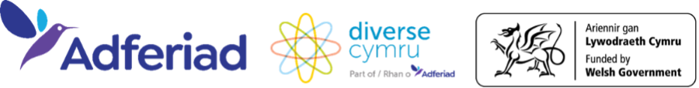
Welsh Culture Grant Scheme for Grassroots Organisations
Glossary of Terms
Unregistered Community Group
A group of people who come together to deliver activities in their community but who are not formally registered as a charity, CIC, or company.
➡️ Eligible only for the Small Grant unless applying in partnership with a fully constituted organisation.
Constituted Group
A group that has a written constitution (a set of rules explaining how the group is run, who makes decisions, and how money is managed).
➡️ Can apply in their own right or in association with a fully constituted organisation.
Fully Constituted Organisation
An organisation with a formal legal structure (e.g. a charity, CIC, or co-operative) that can hold a grant agreement and manage funds on behalf of a smaller group.
Community Interest Company (CIC)
A type of social enterprise set up to benefit the community rather than private shareholders. CICs are registered with Companies House and regulated by the CIC Regulator.
Charity
A non-profit organisation registered with the Charity Commission, set up for charitable purposes and for public benefit. Has a registered charity number.
Not-for-Profit Organisation
An organisation that does not operate to make a profit for individuals or shareholders. Examples include charities, CICs, co-operatives, and voluntary organisations.
Unincorporated Organisation
A community group that is not legally registered (for example, a small volunteer-led club). These groups can apply for the Small Grant only, unless working in partnership with a constituted organisation.
Safeguarding Policy
A written policy setting out how your group protects children, young people, and vulnerable adults from harm. Required if your project involves these groups.
Health & Safety Policy
A written policy explaining how your group manages risks and ensures the safety of participants, staff, and volunteers. Required for medium and large grant applications.
Company or Charity Number
The official registration number given to your organisation when you register with Companies House (for CICs or companies) or the Charity Commission (for charities). Can usually be found on your governing document or registration certificate.
References
Independent people or organisations (not related to your group) who can confirm your group’s work, track record, or suitability for funding. These might be local partners, venues, or community leaders.
Cultural Activity
Any activity that promotes arts, heritage, or cultural expression. Examples include visual art, dance, festivals, literature, performance, and music.
Community Group
A group of people who come together to share experiences, support each other, and deliver activities in their local area. Can be informal or formally constituted.
Freelance
An individual who is self-employed and provides services on a project basis (for example, an artist or workshop facilitator).
Employed
A person working under a contract of employment, receiving a salary and employee benefits.
Project Beneficiaries
The people who directly benefit from your project (e.g. participants, audience members, or community members served).
Volunteers
People who give their time freely to support your project without payment.
Vulnerable Adult
An adult who may be unable to protect themselves from harm or exploitation due to age, disability, illness, or other circumstances.
Capital Costs
One-off costs for equipment, resources, or items that have long-term use (e.g. musical instruments, art equipment, digital tools).
Revenue Costs
Day-to-day running costs of a project (e.g. staff time, venue hire, transport, materials, volunteer expenses).
Costs
The overall budget needed to deliver your project, including both revenue and capital costs.

